**Low self-esteem cycle**

**Do you struggle with low self-esteem? If so, fill each section of this worksheet and identify the root cause of your problem. If you feel as you have a good self-esteem, create an ideal scenario that shows how low-self esteem develops and fill the worksheet accordingly.**

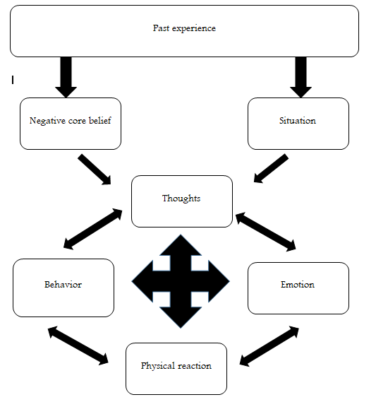

Fig 1. Low self-esteem cycle

Past Experience (The bad thing you experienced in the past) ________________________________________________________________________________________________________________________________________________________________________________________________________________________________________________________________________________________________________________________________

Negative Core beliefs (The negative belief you have about yourself)

________________________________________________________________________________________________________________________________________________________________________________________________________________________________________________________________________________________________________________________________

Situation you faced (Difficult situation)

________________________________________________________________________________________________________________________________________________________________________________________________________________________________________________________________________________________________________________________________

Your thought (the way you interpreted the situation)

________________________________________________________________________________________________________________________________________________________________________________________________________________________________________________________________________________________________________________________________

Your behavior (The way you reacted)

________________________________________________________________________________________________________________________________________________________________________________________________________________________________________________________________________________________________________________________________

Your Emotion (The way you feel about yourself)

________________________________________________________________________________________________________________________________________________________________________________________________________________________________________________________________________________________________________________________________

Physical reaction (The way your body reacted

________________________________________________________________________________________________________________________________________________________________________________________________________________________________________________